Serenje

It is a major community in north central Zambia. Its population numbers about 160,000. It is the largest town in the area. It is located in the Central Province of Zambia. The congregation numbers about 100 or so. It is the only congregation in the Boma (town). However, there are 14 congregations in the area around the town.

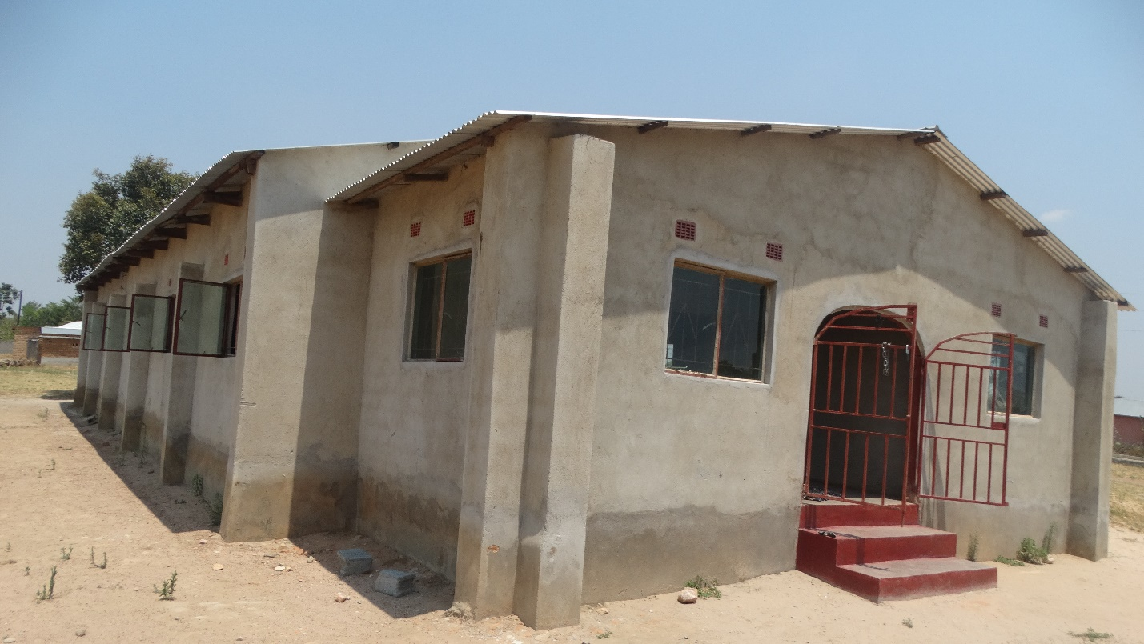

I do not know when the congregation was first begun. I do know that it was in existence when I first visited Zambia in 1999.

Serenje will be the last on our travels to the North. We will study the book of Ephesians in the time that we are here. ( I learn after the 1st day that we will only be with the congregation here for 2 days instead of 3.)

Since we are visiting these congregations during the week the attendance is not what we would prefer. However, our purpose is to strengthen and encourage. We can do that with those present.

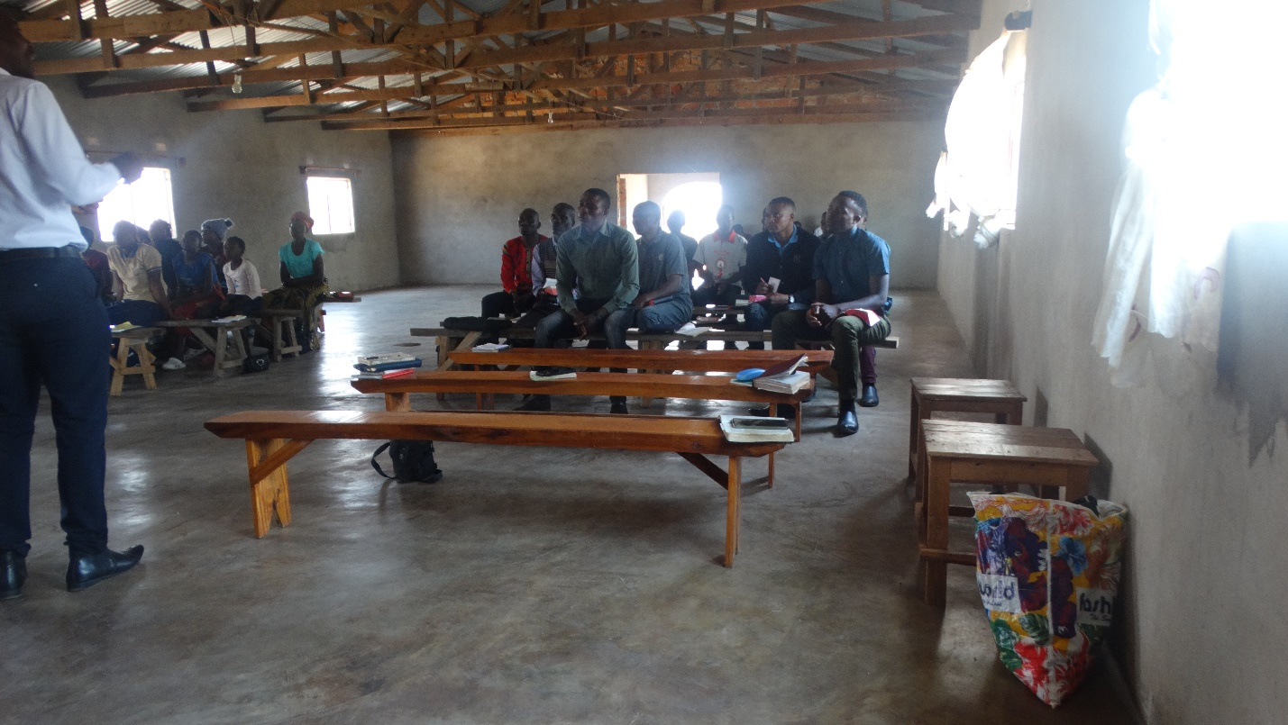

There was good interest and participation in the congregation. Charles said that the church leaders/members were quite happy with our study.

The first day of our study we were visited by two brothers from Chishi. After their talk with Charles and insistence that we visit them our schedule was changed. We will take the third day with Serenje and visit the congregation in Chisi.

There were three baptized at Serenje. ( I am still trying to collect the pictures.)

Chishi is a strong congregation of over 100 members. It is located quite literally in the bush. The road to Chishi is a bush road.

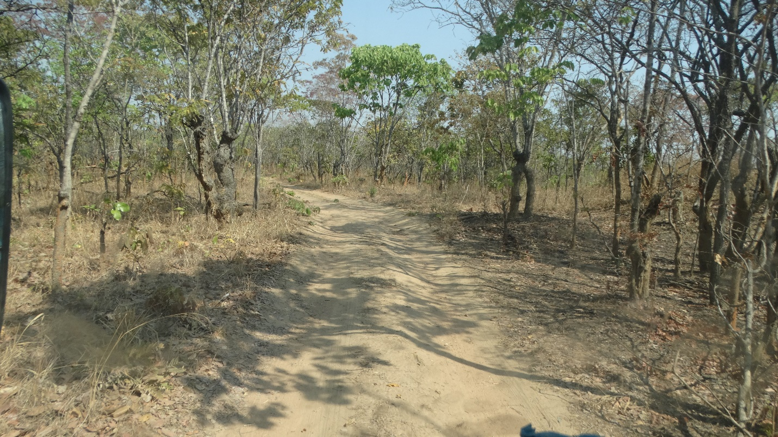

The congregation is locate just over 40 km outside of Serenje. It was begun by a remarkable brother several years ago. When I last visited the walls of the building were only up about 3 feet. It has since been completed.

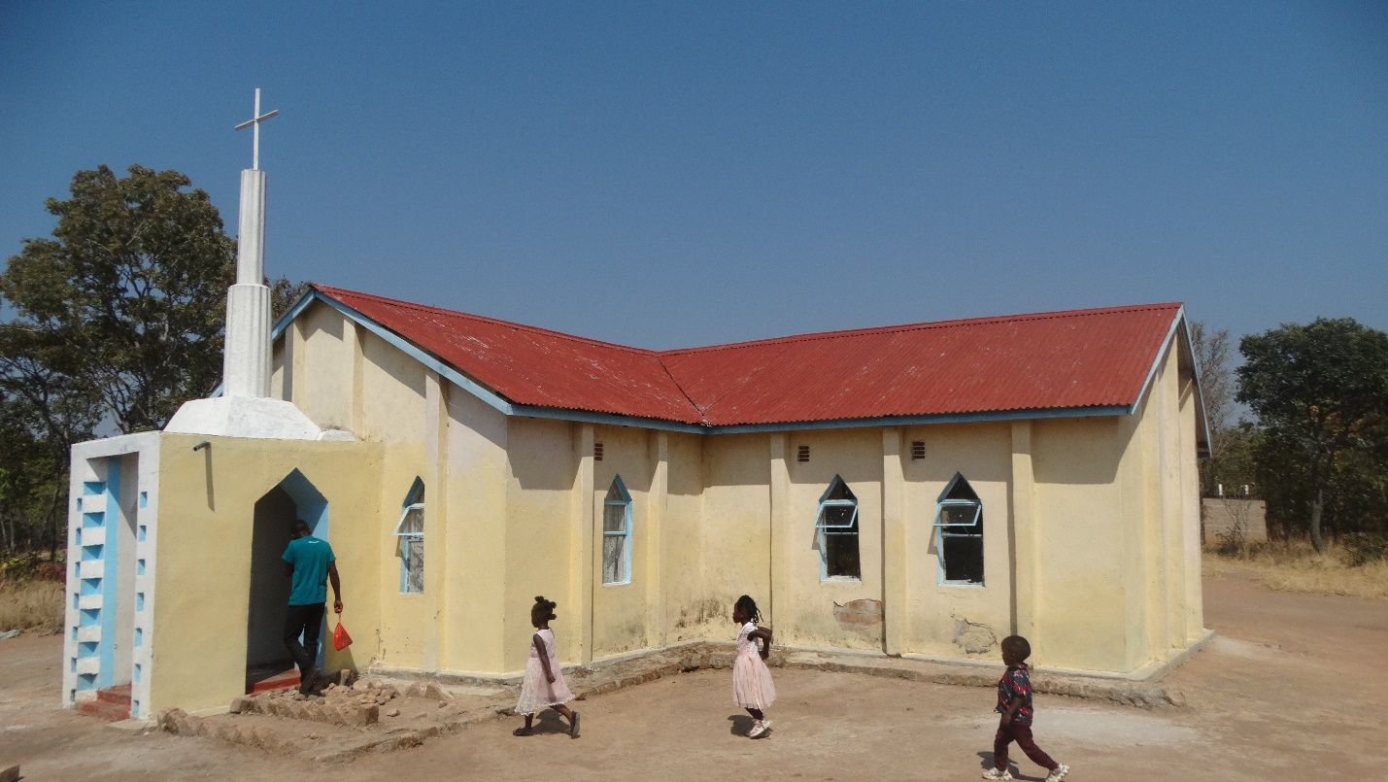

The building was built in the shape of a cross. The podium/pulpit is in the middle the sections. It is interesting to speak with people sitting on 4 sides.
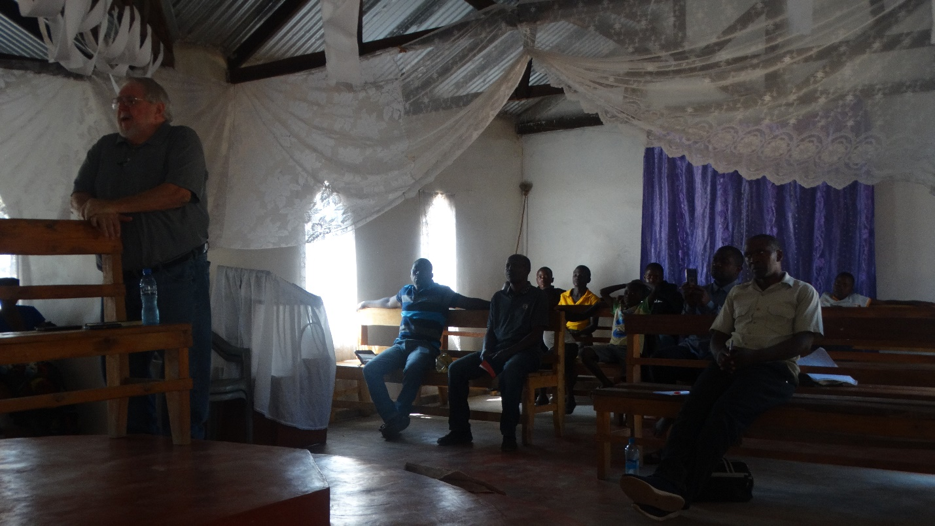

At the invitation we had several respond.

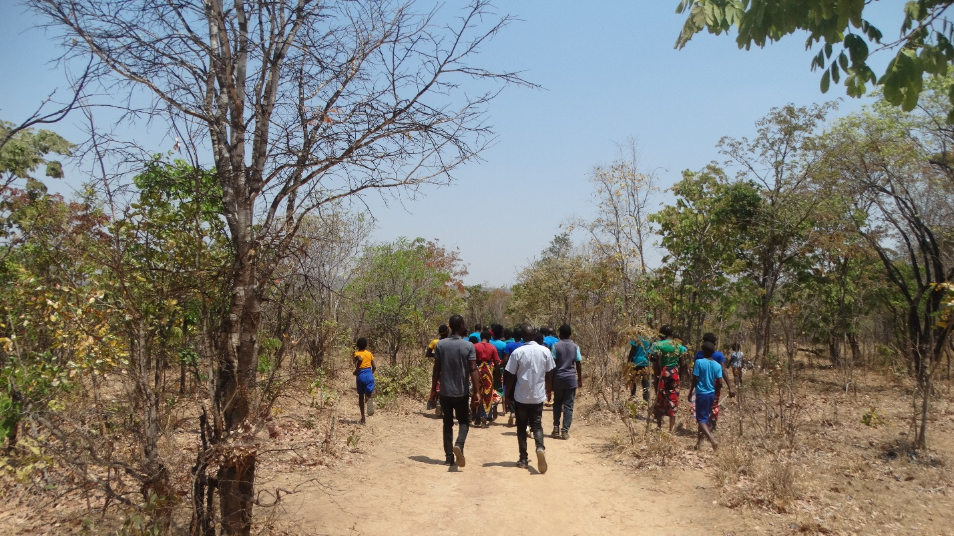

Three were baptized. Here is everyone walking to the river.

The next day we traveled to Kabwe to spend a couple of nights. Then it will be Siavonga and the end of the program

God bless!
Charles
Serenje/Chishi

