September 8

Today our program begins in earnest. We will be departing Kabwe to travel to Kapiri Mposhi. We should arrive about midday. The teaching will begin this afternoon. I have been asked to teach the book of Ephesians this year. So, in each location we will study Paul’s letter.

I have not visited Kapiri since before I lived in Zambia. The churches in the northern district have been asking Charles that we return. During this trip I will have a chance to see how congregations are doing that we planted.

We arrived in Kapiri near 1:45pm and checked out the lodging. We secured a room and headed out for the church building and the first of our sessions with the church. FYI – Kapiri Mposhi means “small hills of Mposhi” in Nyanja. There are several small hills visible for miles from which the name is drawn.

We had one session on our study of Ephesians. This first one was much more of an introduction not only to Ephesians but to Bible Study and revelation.
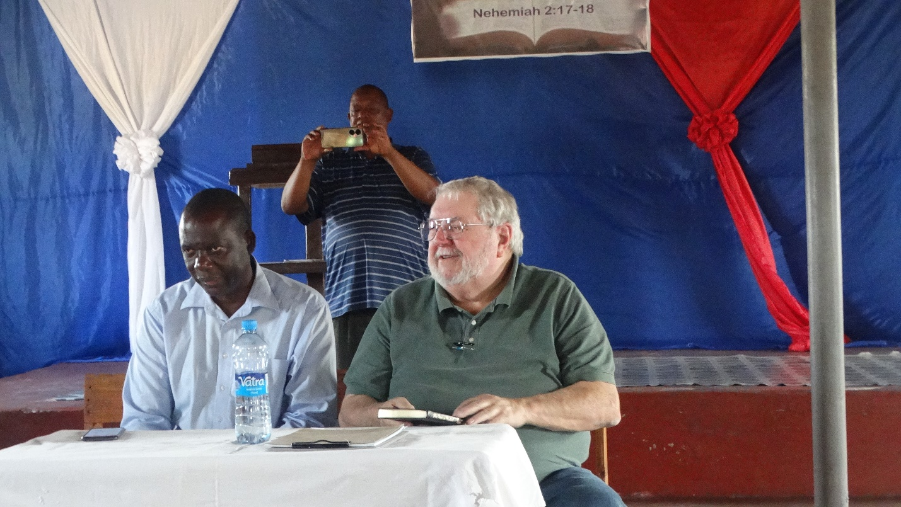

September 9, 2023

This day I will speak in six sessions throughout the day. Our goal is to cover the book of Ephesians in its entirety. I like to cover not only the text but connect it to other statements that bear on the topic. I also like to include as much historical background as possible. I believe that it is important in helping Christians mature that they see the real-world context of Scripture. Too often people develop a very one-dimensional view. In my judgment this tends to make it dull.

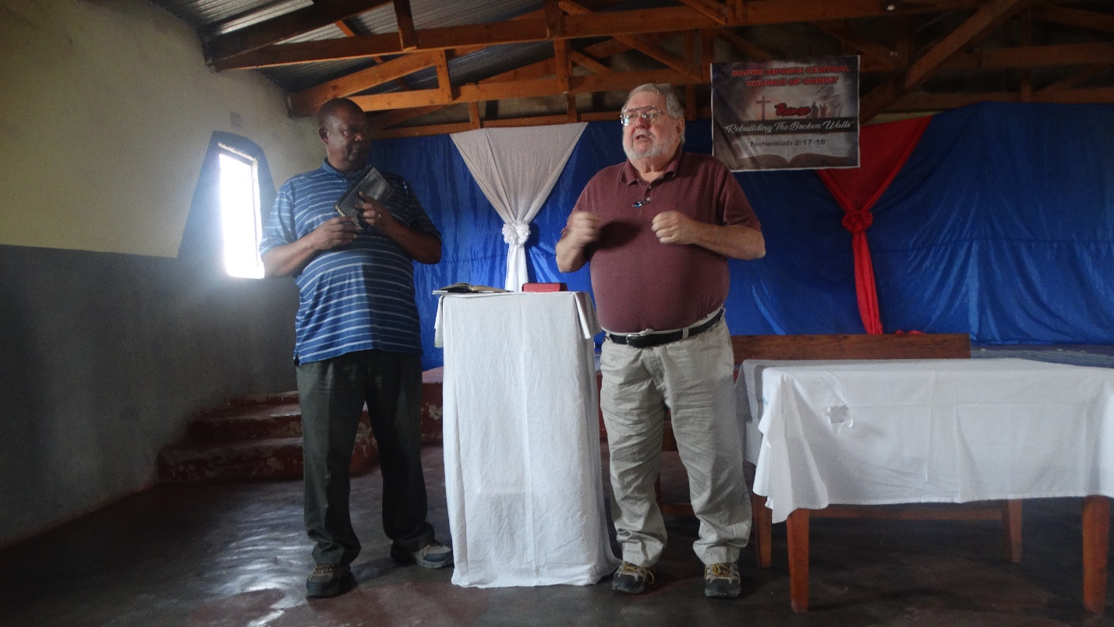

During this session my brother, Charles Phiri. When I say brother, I mean more than just in a Christian sense. We are family, brothers. I view his children as my children, and they see me as their Papa. He is a capable and dedicated preacher of the Gospel. When he translates, we have a familiarity that allows the speaking to flow easily.

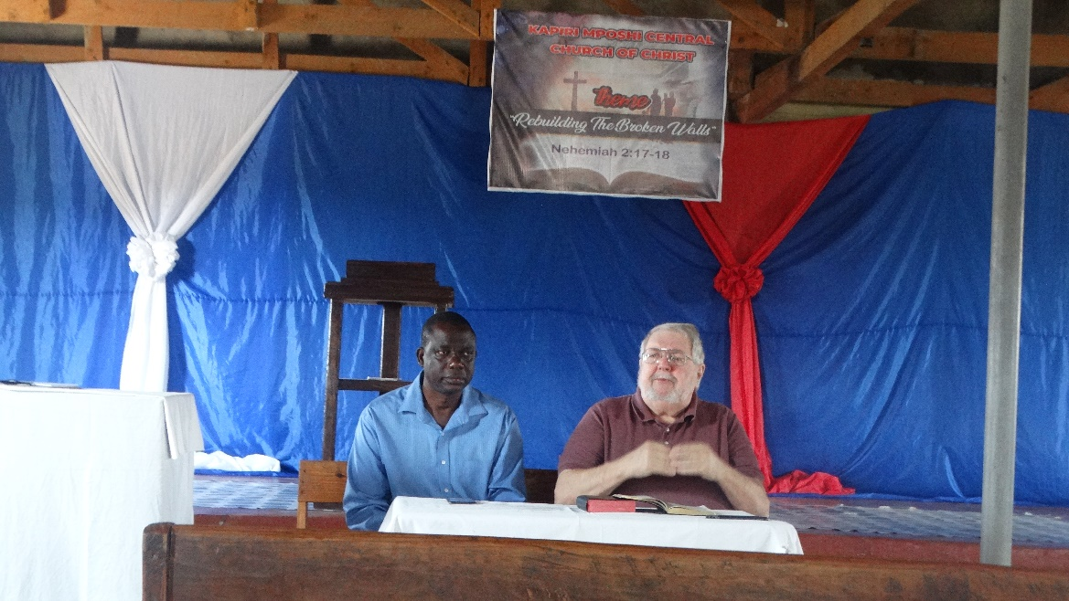

Since this is teaching and I will be doing so for about 6 hours today I do much of it sitting down. The brother next to me is Solomon Mutanga from Kapiri. He does most of it for the day.

The church in Kapiri numbers over 100. I understand that it has numbered 300 in the past but, due to some difficulties, it has reduced to its present size. It has 4 shepherds. Our attendance for the Saturday session was just over 50. On Sunday I will teach the Bible class and we will have two more sessions in the afternoon.

By the time the day is finished I am really worn out. We return to the lodge to rest. Later we go back to the church building for dinner. I have rice and chicken. Afterwards we return to our lodging. I turn out the lights at 9:45. The alarm is set for 6am. Sunday.

God bless!
Charles
Kapiri Mposhi, Zambia

