September 16-18 – Isoka

Isoka church is one that we planted a few years back. In the years since we last visited the church they have built a building and are doing well.

At our last visit the main street of town was a dirt road. Since that time it is now paved with a round-about at the main junction. I notice that there are many more buildings that at the last. The lodge that we are staying in was not here then.

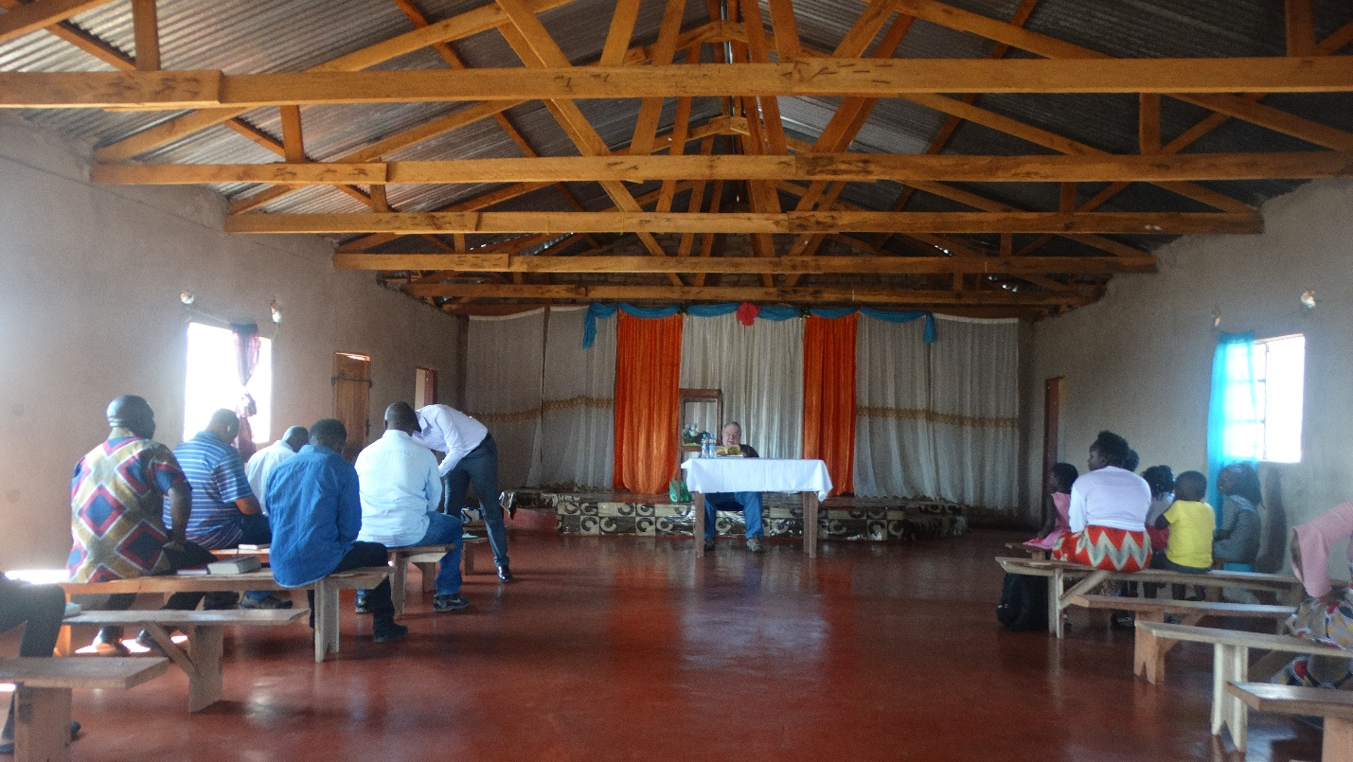

Attendance during our study varies. Isoka is not a large congregation but it is solid and it is united, unlike some in Zambia. The attendance varies due to individuals employment obligations. One very strong lady is the pharmacist at the hospital. She was called into work and was unable to attend many of the sessions. However, our first night in Isoke we were invited to her home for dinner, it was very good.

Since our goal is to encourage and strengthen I am keeping everything low key and oriented toward learning. Our presence is an encouragement. Plus, when Charles speaks he really gets worked up, especially if he slips back into Nyanja from English.
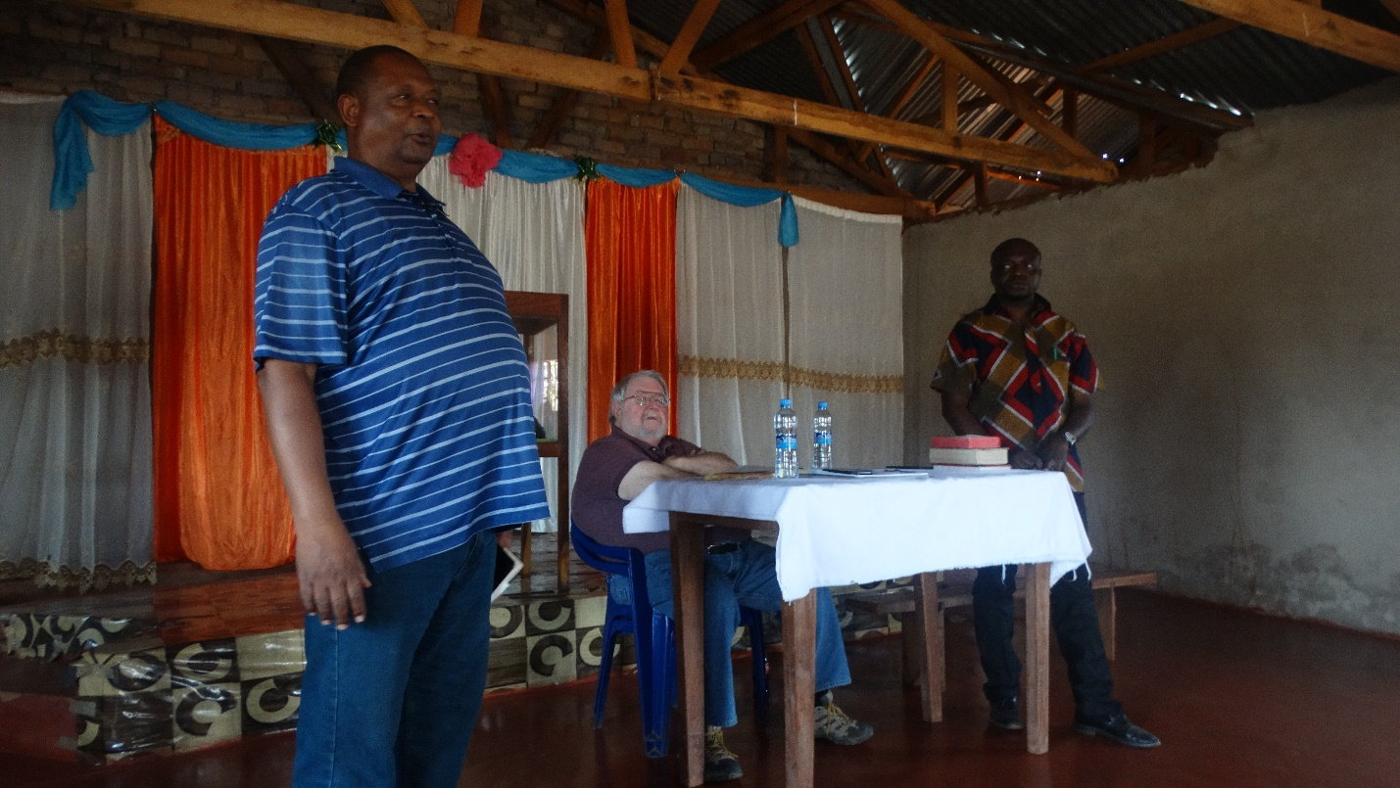

One thing I will do, if I have a song book, is to sing along with the congregation. In Nakonde there were no books so I could only listen. But, it is interesting that in Nakonde even though not many had books when the song leader was ready he would call out the number. In Isoka I have a song book so I sing along.

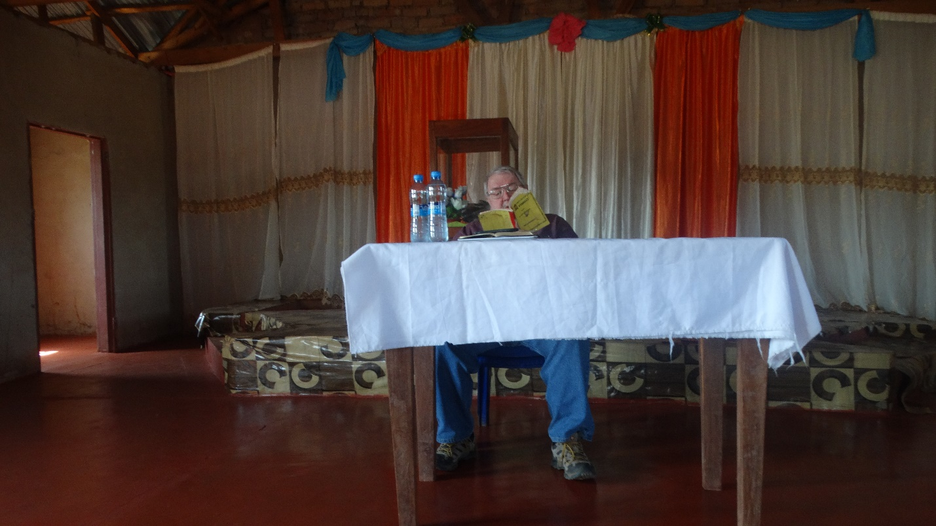

I suppose I am singing in a tongue. i.e. I do not understand it but those singing along do. All in all it is a good effort and the fellowship is greatly appreciated.

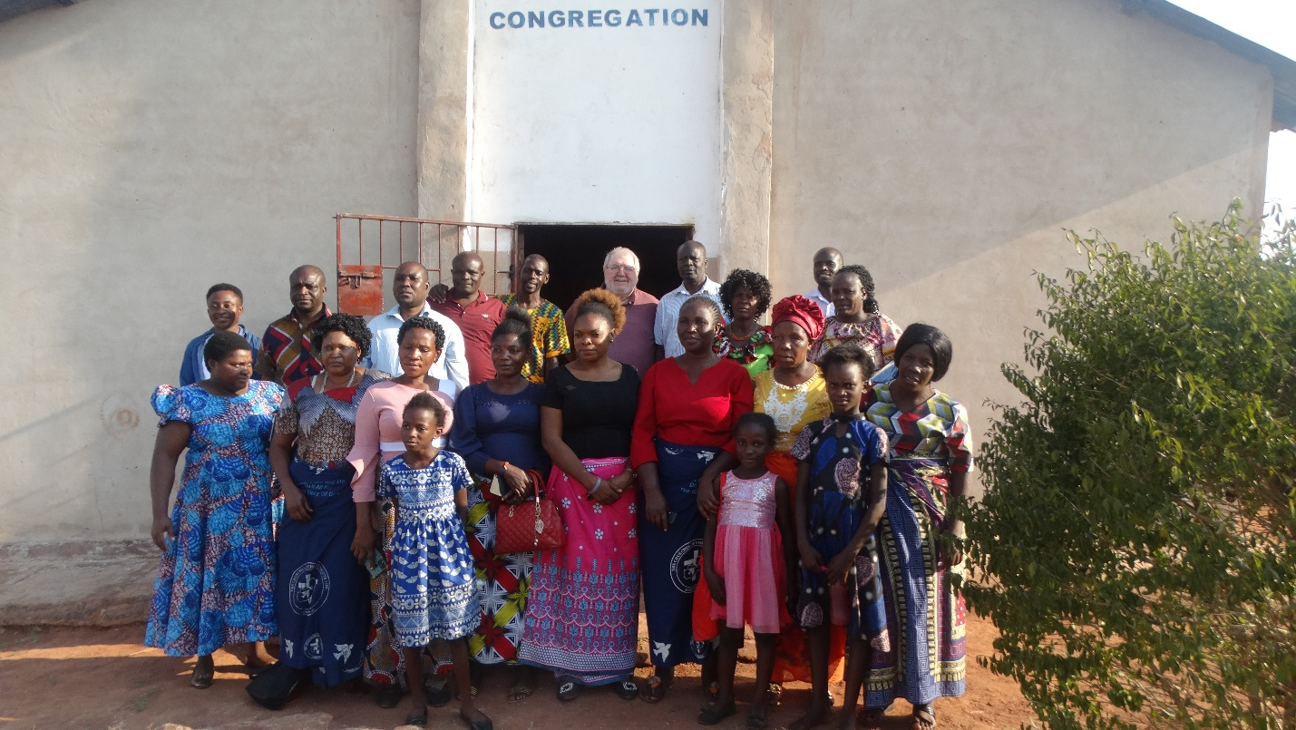

We take our leave to return to lodging for supper and to prepare for our departure tomorrow for Chinsali about 120km south.

God bless!
Charles
Isoka, Zambia

