September 14

This is our last day in Nakonde. It has been a good effort. The brethren have appreciated our study of Ephesians. Our purpose was to strengthen and encourage the church. I believe that we have accomplished this. The church has also affirmed this is so.

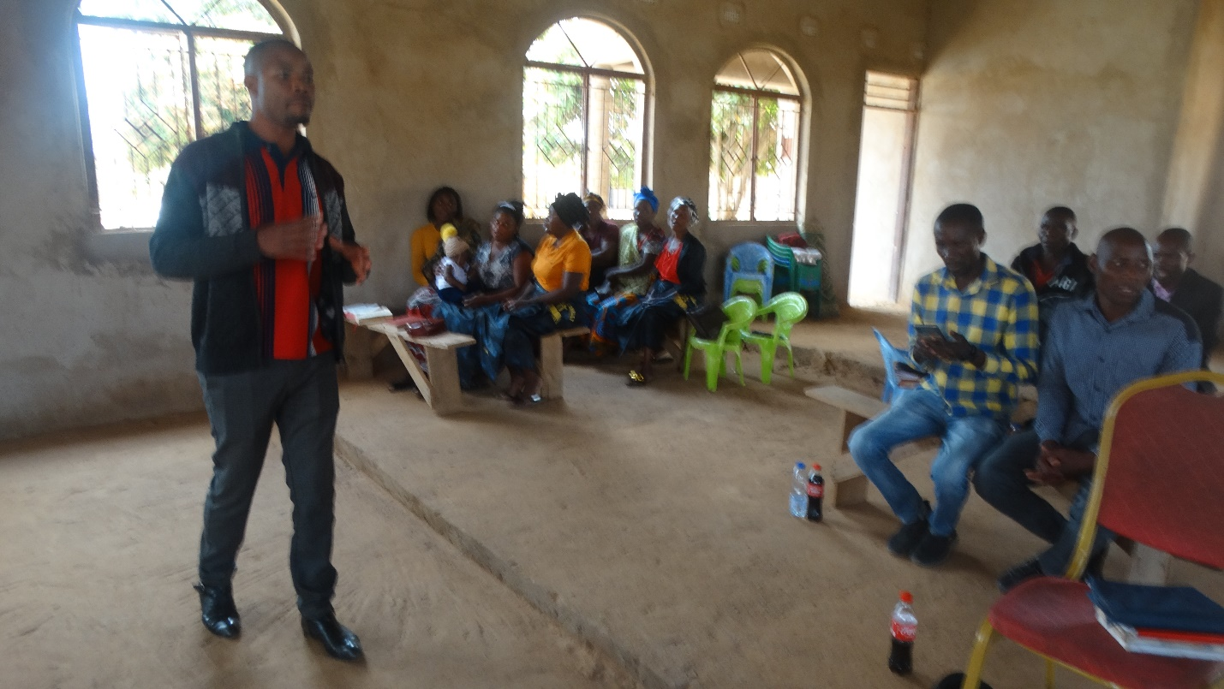

On the last day of our visit we found that a couple of members have tendencies toward some Charismatic beliefs. This is frequently the case in Zambia. But, it seems that the church as a whole does not support such thinking. We are certain of the state of the church in spite of this.
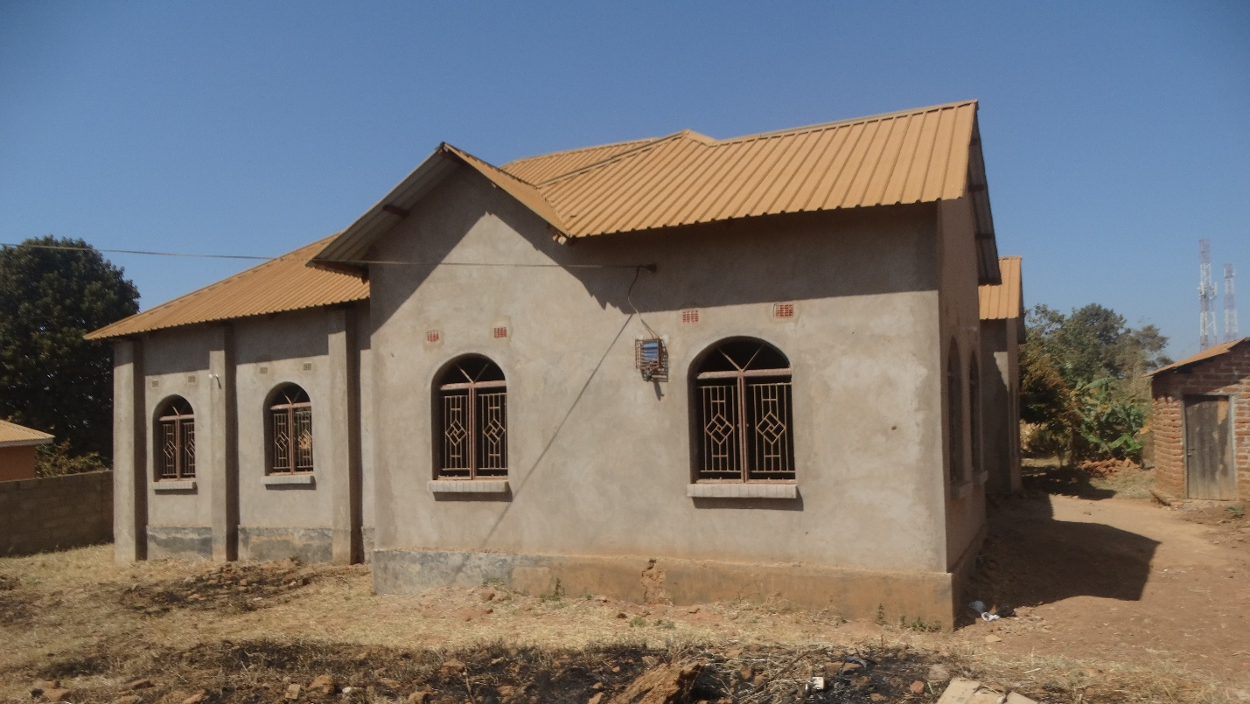

Nakonde building.

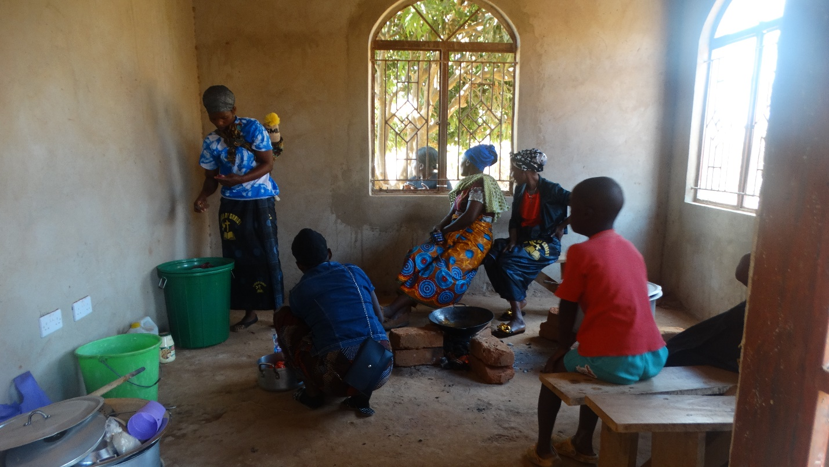

The kitchen…

We spent a couple of hours answering questions with the church before closing our program. It has been a good effort. We return to our lodge and prepare to depart tomorrow for Isoka.

September 15.

Do day is a day of travel. But it will not be a long day. Isoka is about 100km from Nakonde. We travel there and locate the lodging and settle in. A church member meets us and we go to the church building to see it. The last time I was in Isoka they did not have a building but rented space in a local school.

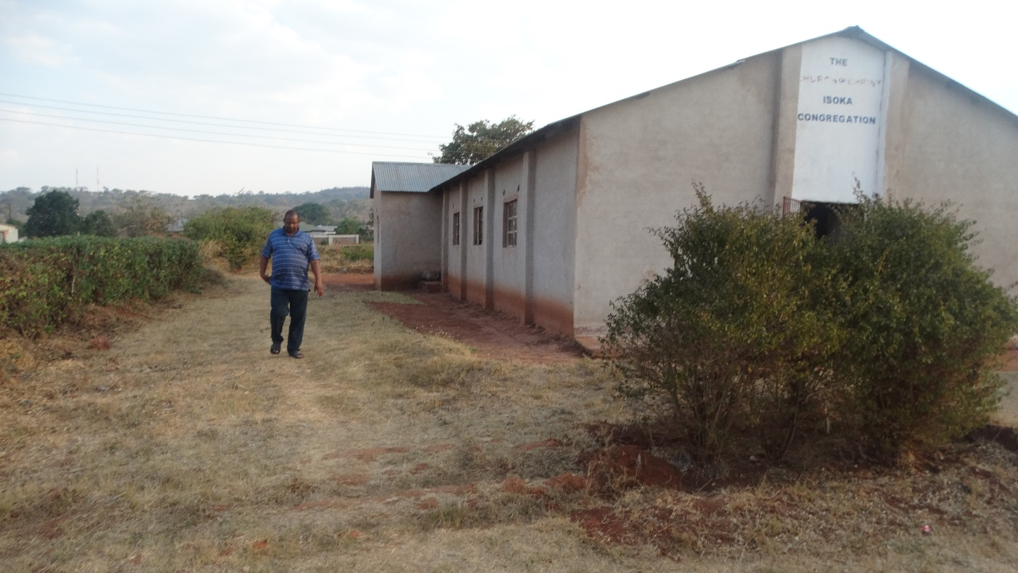

They have come a long way since then. Tomorrow we will begin our program.

God bless!
Charles
Isoka, Zambia

