September 11

Today is a day of travel. We are headed for Nakonde on the border with Tanzania. It is about 850 kilometers. We are not sure if we can make it in a single day. We are not expected in Nakonde until Tuesday afternoon.

We made good time to Mkushi. The road to Mpika was not too bad but after Mpika the road deteriorated and we were required to slow down and avoid the potholes. There were places where there was little pavement. The result was that we made it as far as Chinsali as it was getting dark. Chinsali is about 230 km from Nakonde. We found lodging for the night. We will go in on Tuesday.

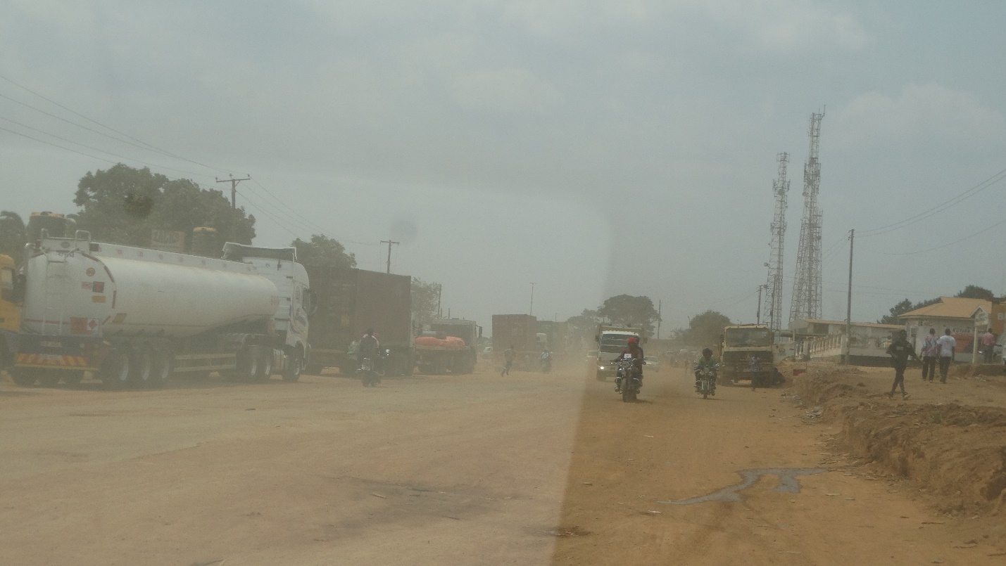

Our original plan was to arrive around 2pm and have a couple of teaching sessions in the afternoon. However, we arrived much later and could do little more than greet the brethren and look for tomorrow to start the study.

September 13

Our program today was to begin at 9am. However, as usual, almost no one was here at 9am. It was closer to 10 before we were able to begin.

We do not see many brethren present. Nakonde is a border town. Members will work in businesses as clearing agents and other related jobs. It is not easy for them to take time off. In Zambia it is not always about large numbers. The congregation in Nakonde numbers 40 or so.

Our purpose is to strengthen and ground the church.

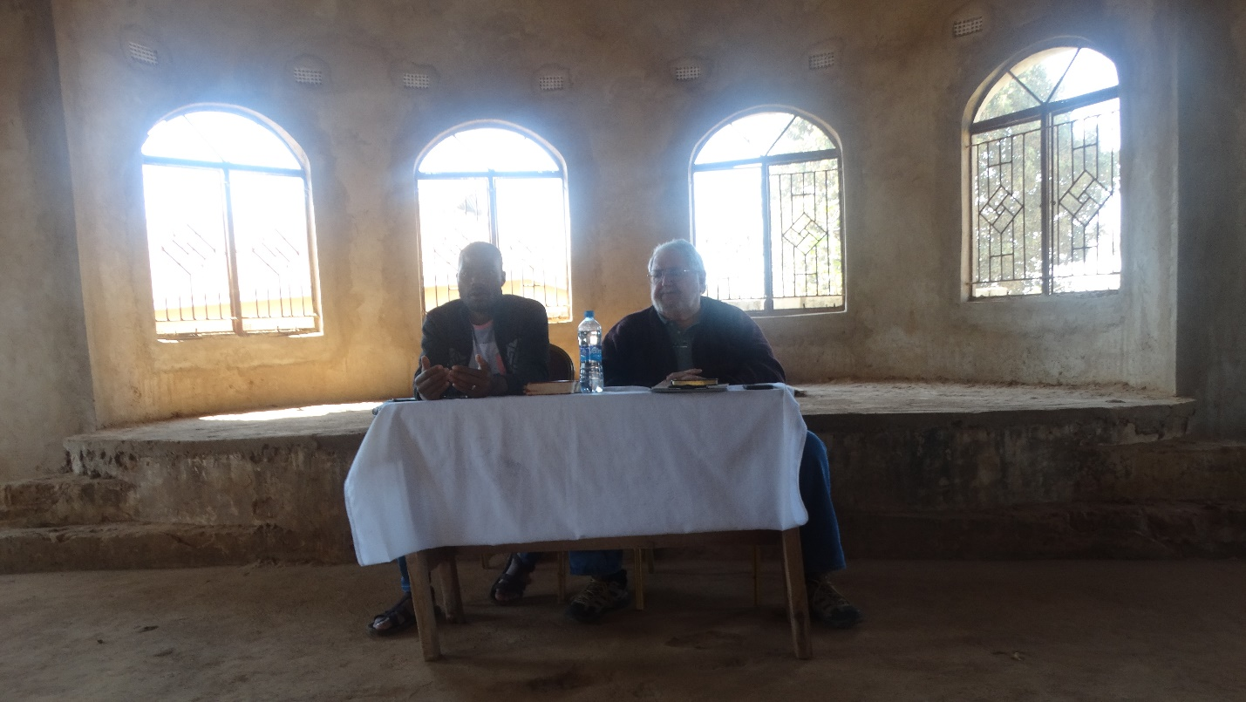

The brother translating for me is named Pride Pukin. He is an intelligence officer for the government. He is one of the leaders of the church. I remember him from the last time I came to Nakonde. He was my translator then. But he was trying to translate and take notes at the same time. He is knowledgeable and a strong influence in the congregation here.

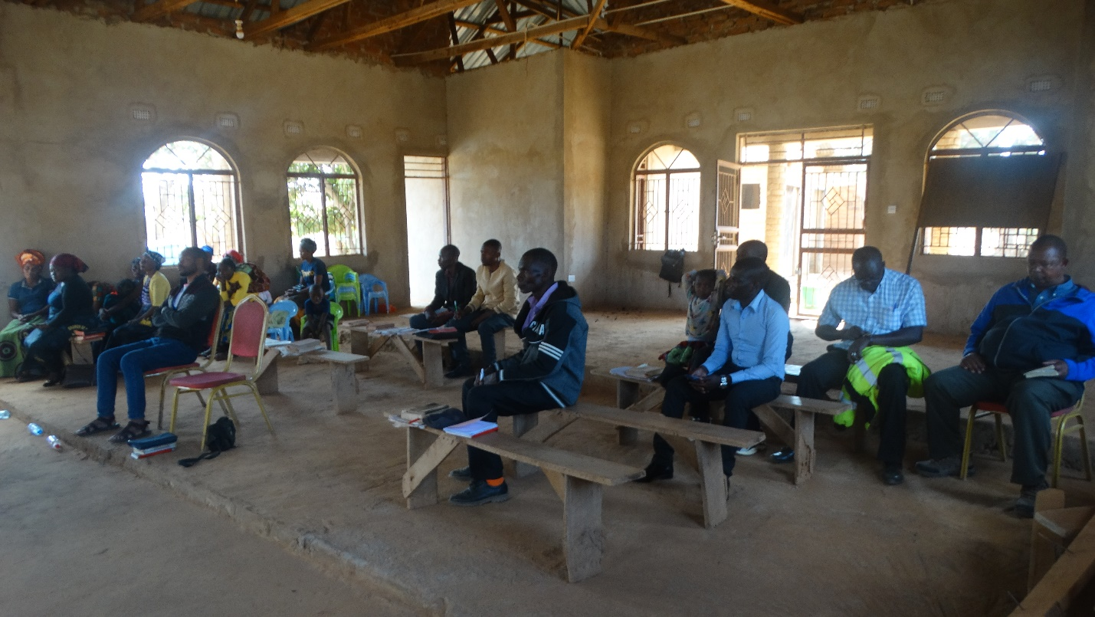

The last time I was in Nakonde the church was renting a classroom at a local school. They now have their own building to meet in and are doing well. One of the challenges for a congregation like Nakonde is that often members come and go because of the border businesses. Pride is the head of the district where Muyombe is located. Muyombe is 180km away. But he lives here because the school is much better for his children.

We had one member respond and request to be baptized. At the end of the day, he was baptized in the local stream.

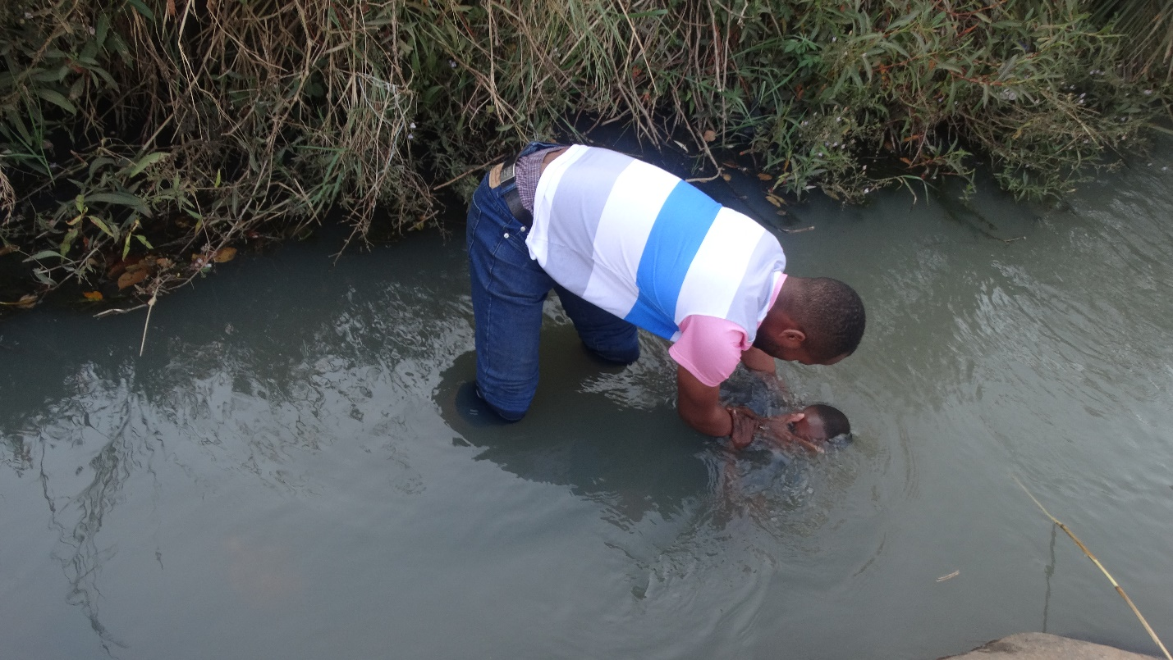

It was a good day. The church was encouraged and, I believe, strengthened in the Word.

God bless,

Charles

Nakonde Zambia