September 10

Today we will have services. I am to teach Ephesians at Bible Class. Charles will preach and elder Loloji will lead the Lord’s supper.

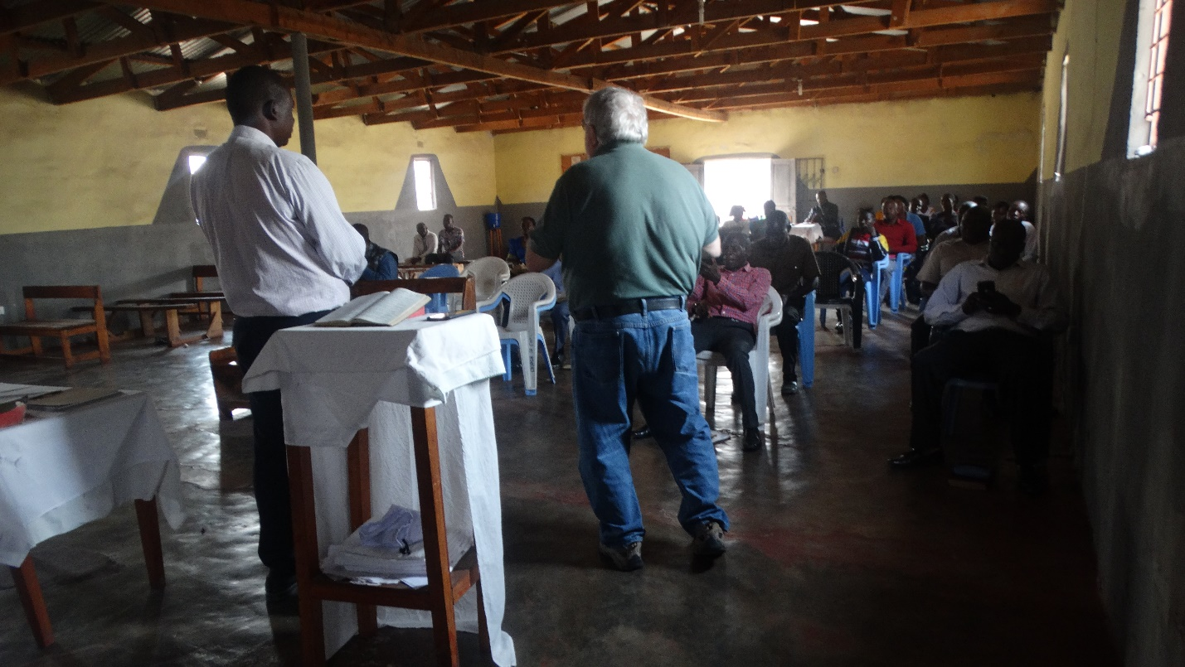

We are not sure how many will be present. As stated before, the church has suffered from some losses in the past, but we do expect above 100. As is usual, in Zambia and the US, people are coming in all through the class. When the time for services there is a pretty good crowd. We learn later that there were 120 of all ages present.

The schedule of the services is less complicated than it tends to be in the USA. Following Bible class there was a 5 minute break. Then as song leader led 2 songs and it was time for Charles to preach.

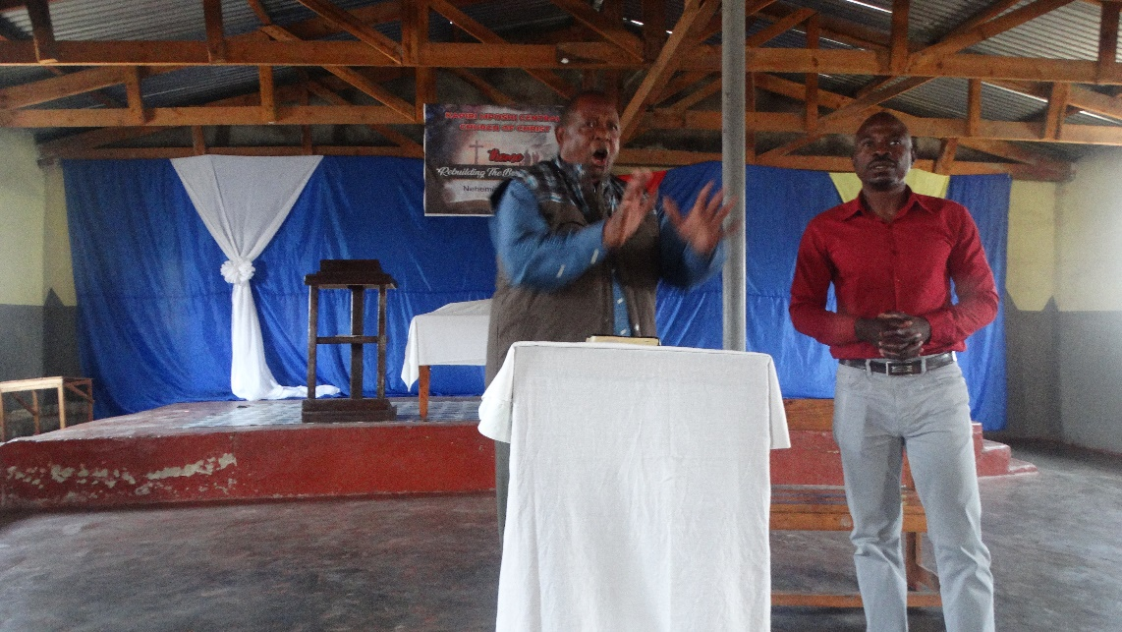
I always enjoy watching Charles speak. He really can become animated. What was amusing to me is that he was preaching in English with a brother translating. But, occasionally, he would revert to Nyanja instead of English. I do not think he even realized it.

When the time came for Loloji to lead communion, Charles said that he spoke for 20 minutes longer than Charles’ sermon. Hmmm!

Lunch was delayed so I started my afternoon session in Ephesians. My plans were to complete the book by 1400 (we did, just). The numbers in attendance were a bit lower. Some who had come from a distance had to leave to get back home. But things went well.

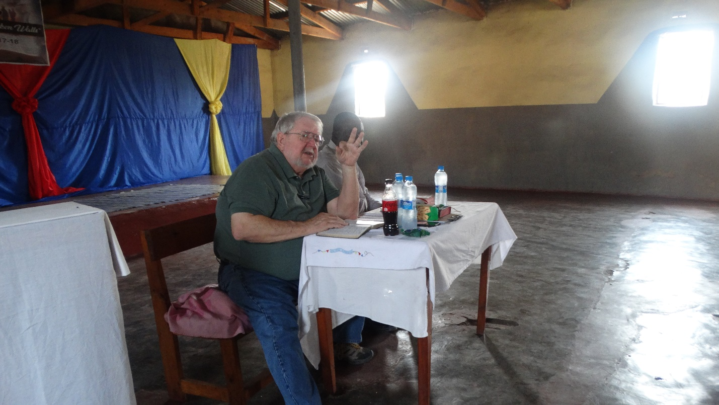

Our program ended just before 1400. However, several individuals spoke to say thanks etc. and we finally concluded about 1420. After goodbyes we headed to our lodging to prepare for our departure for Nakonde.

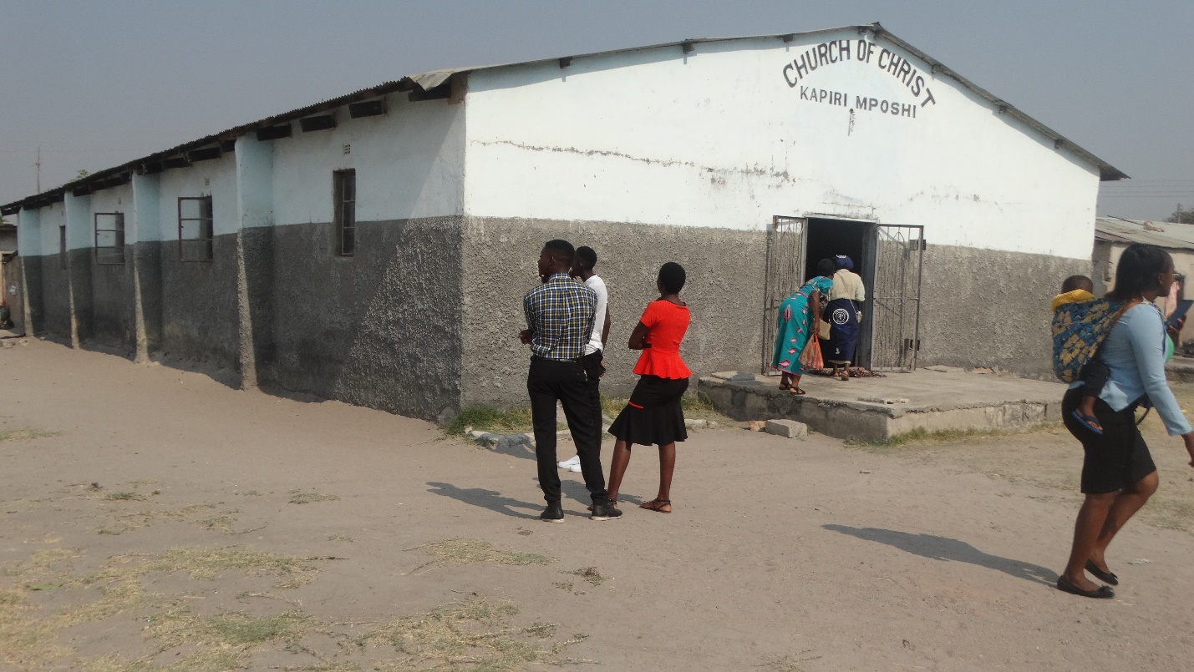

The building is fairly typical for most in Zambia. It is cinder block with wooden rafters and corrugated sheet metal roof.

Tomorrow is a day of travel.

Charles
Kapiri Mposhi, Zambia

