Southern Africa Bible College

I arrived around 9pm on Monday Sep 4. I was met by 4 of the male students. They asked me a lot of questions during our 40 minute ride to the school. When we arrived I was shown my room and prepared for sleep. I had been up since 7 Sunday morning and was ready to sleep.

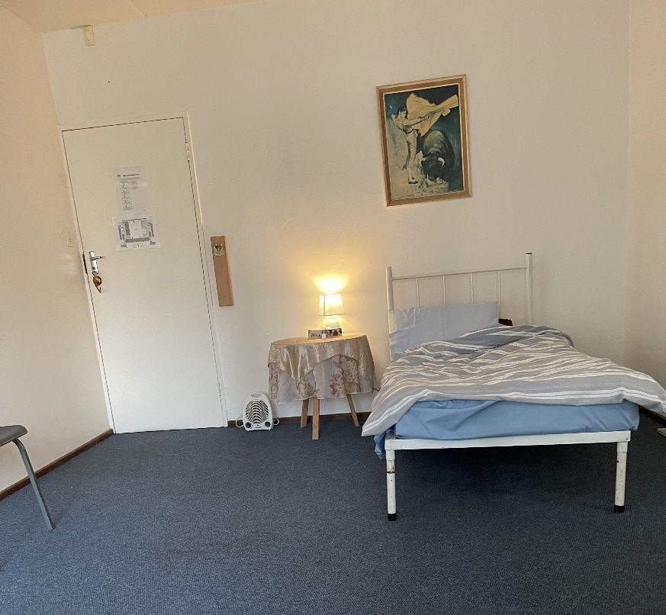

The next morning I had breakfast in the kitchen area and began to meet the students who came in one at a time. I was surprised at the numbers. It seems that COVID really hurt the school as far as census goes. But they are beginning to build. Apparently South Africa was much more severe in their limits and restrictions. They are looking for a number of new students this next year’s term.

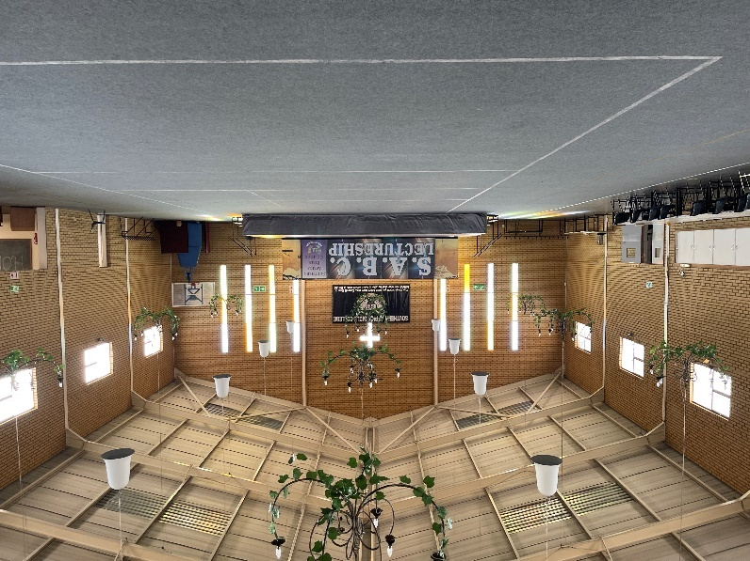
This picture is the large meeting hall. The kitchen is on the left behind those white removable panels. The students eat at the tables. As you can see they have begun to prepare for their annual SABC Lectureship coming in early October.

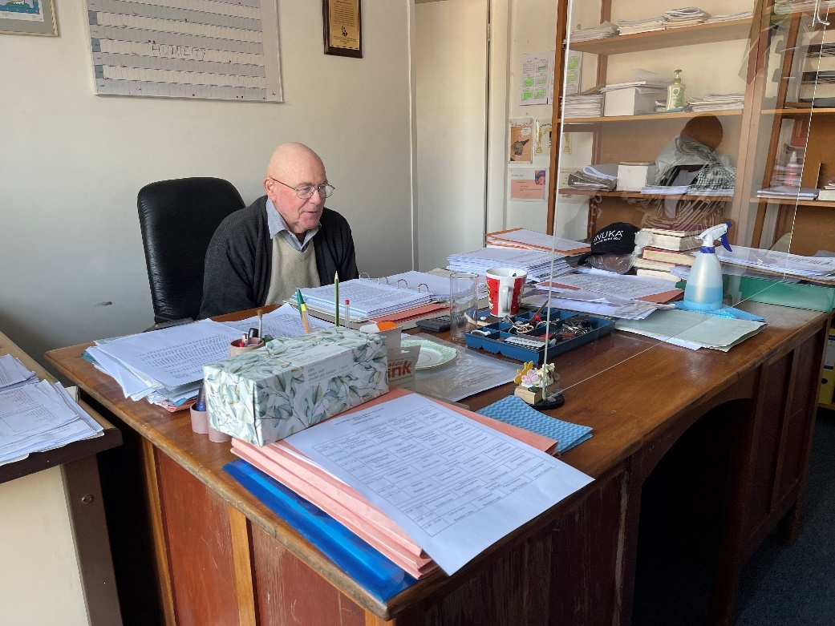

Here is Theo Rappard the head of the school. He is teaching his class on Ethics. I sat in on the class. He had 2 Third year students.

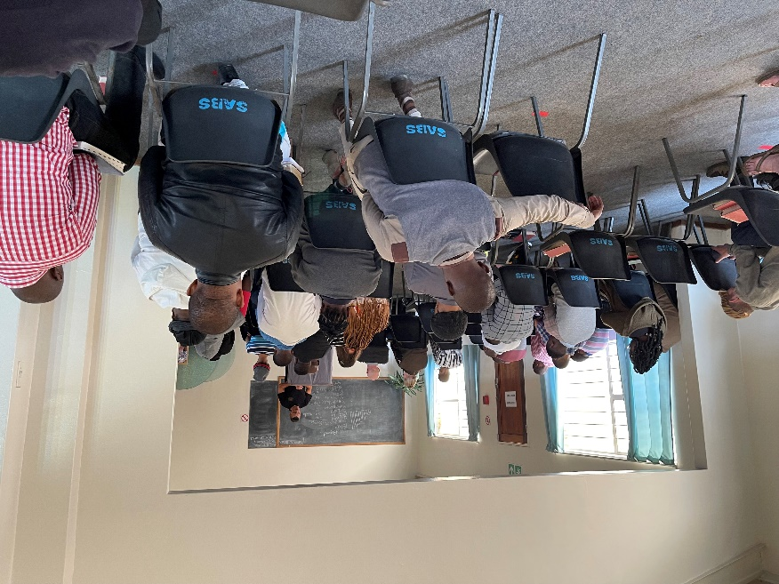

This is the mid morning devotional. I was asked to speak briefly for their devotional time. It was an informal session but enjoyable.

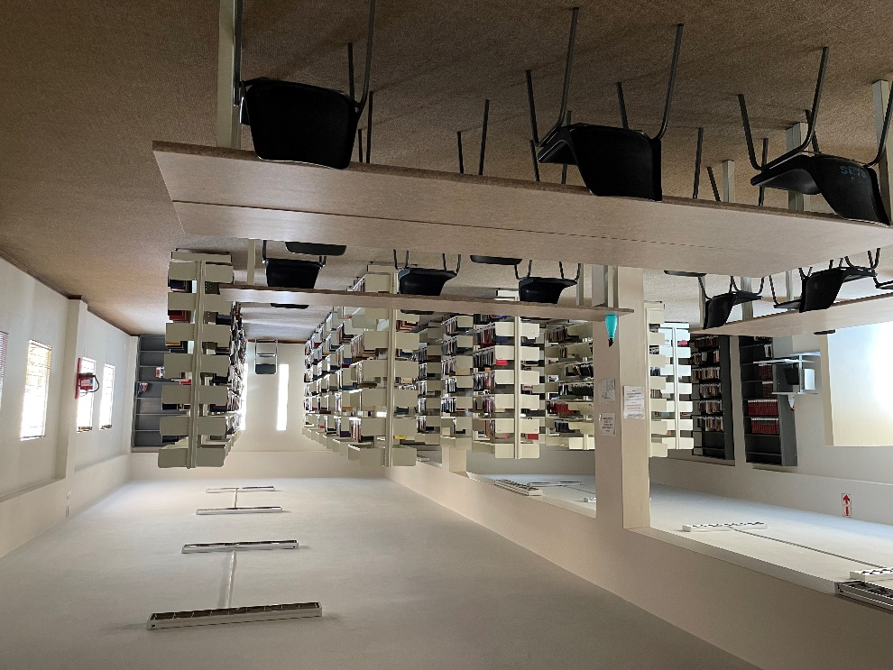

This is the major part of the school library. There is another room off to the side with more books but it was not lit. There are still over 1000 books that have yet to be catalogued.

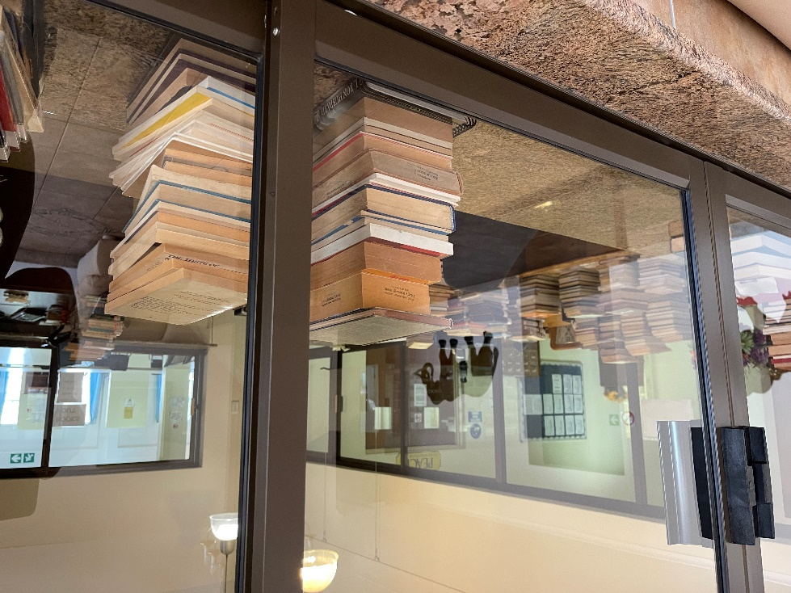

The campus is larger than the picture that we have seen. There are two large buildings and several married student houses. All this sits on several acres of land in the town of Benoni.

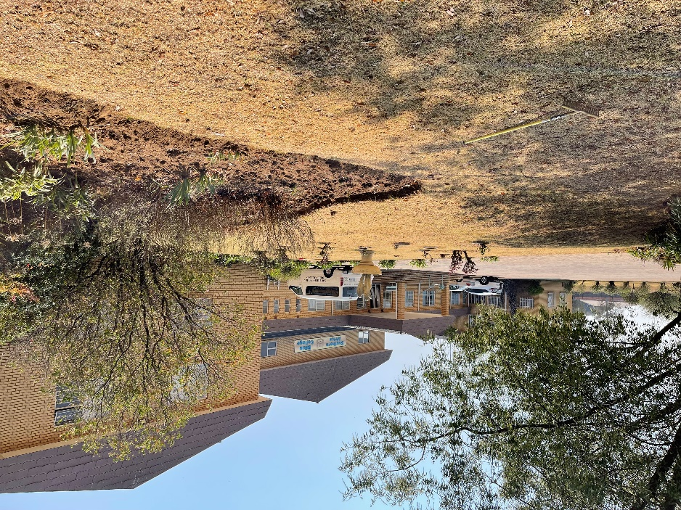

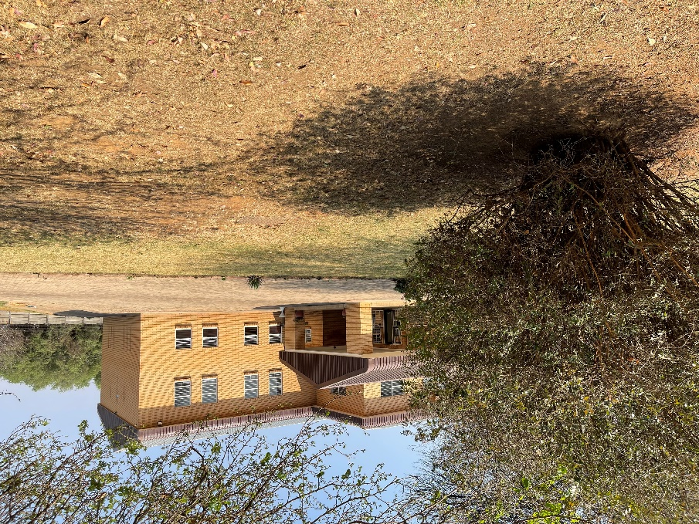

This last is a copy of the classes being taught this year.

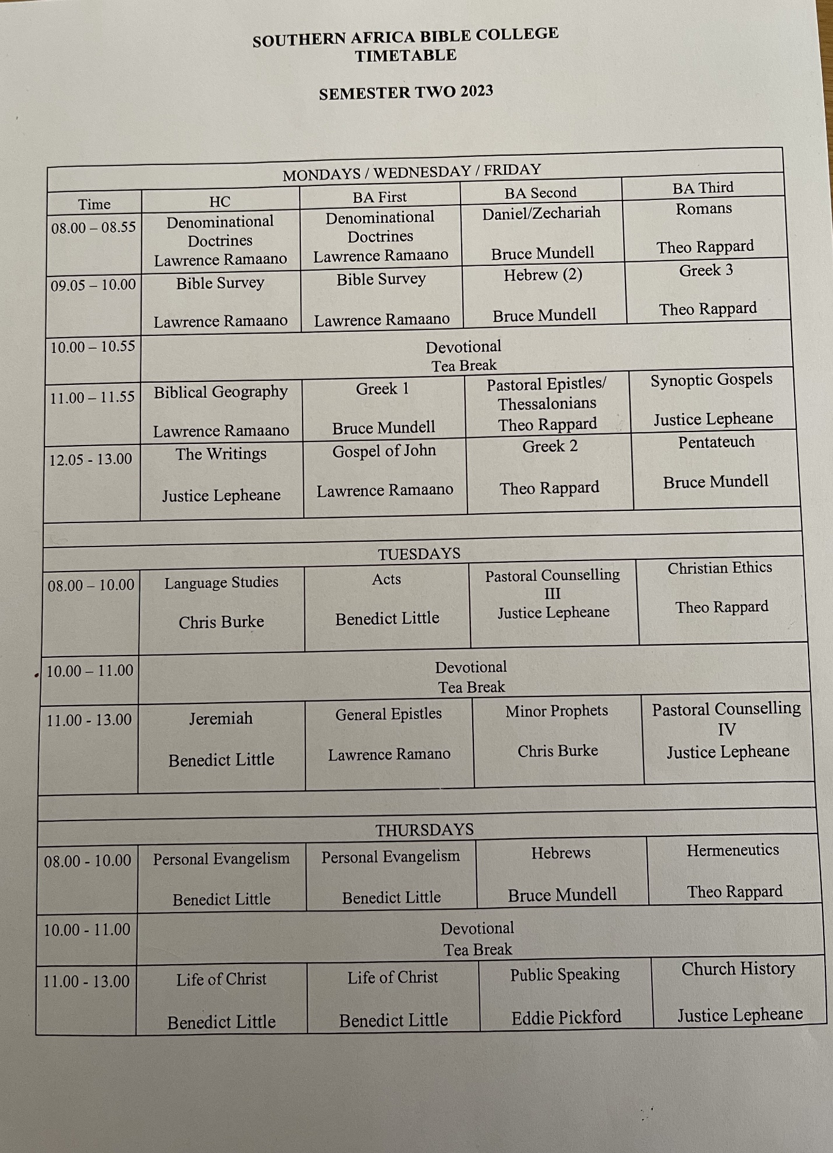
It was a productive visit. I will be able to answer questions to any who wish to ask.

Charles

