Chinsali

Chinsali is a community of just over 15,000 in population. It is the regional “capital” of the Muchinga district. It is a busy community but not a “city” by any means.

Charles and I planted the congregation in Chinsali about 10 years ago. It began with 4 baptisms. Since that time it has gone through the usual struggles of new congregations. In Zambia a congregation will struggle with our strong leadership. It will usually take one strong many to keep things together and moving along. A strong woman is a genuine asset to the church but in this culture it takes male leadership, especially in the beginning. They second time we visited the congregation we met a young man who was in his last year of school. His name was Kelvin. He wanted to attend Mapape Bible school. We arranged that for him after school.

Kelvin went to the school and returned to Chinsali. We find him today, no longer the adolescent we know. He is married with 3 children. He is a business man owning and operating several businesses. His oldest has been baptized and his wife is active in the church. He is the strong male leader.

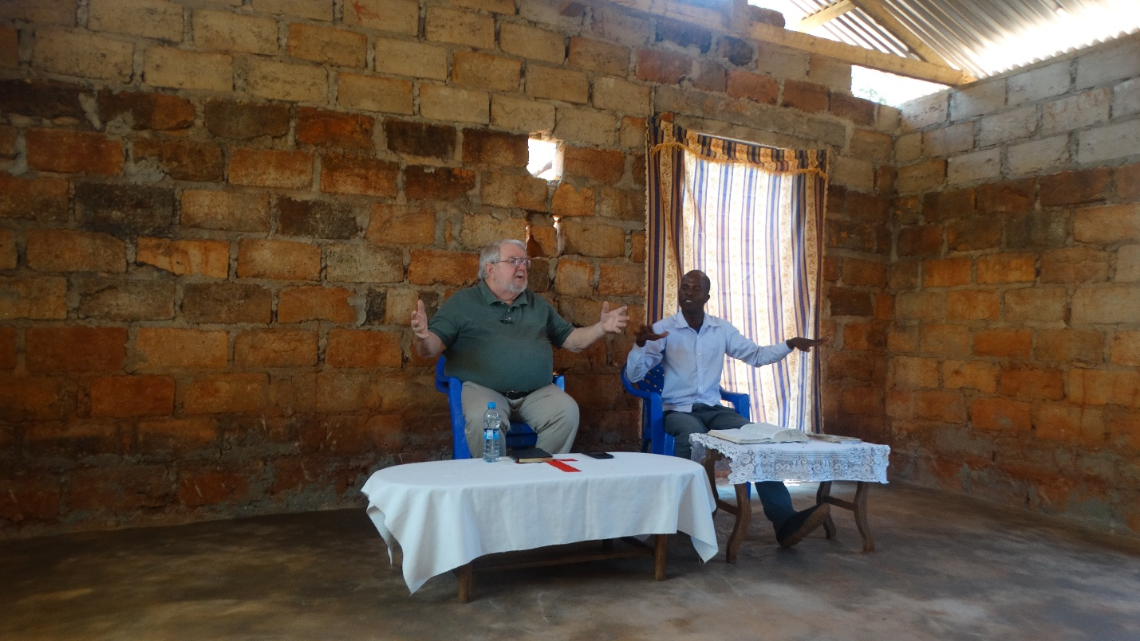

This is Kelvin translating for me. He is still the quiet young man I remember.

The church here numbers about 30. But they have managed to build a small building in which to meet. It is unfinished as yet. I believe that it could hold as many as 100 in attendance.
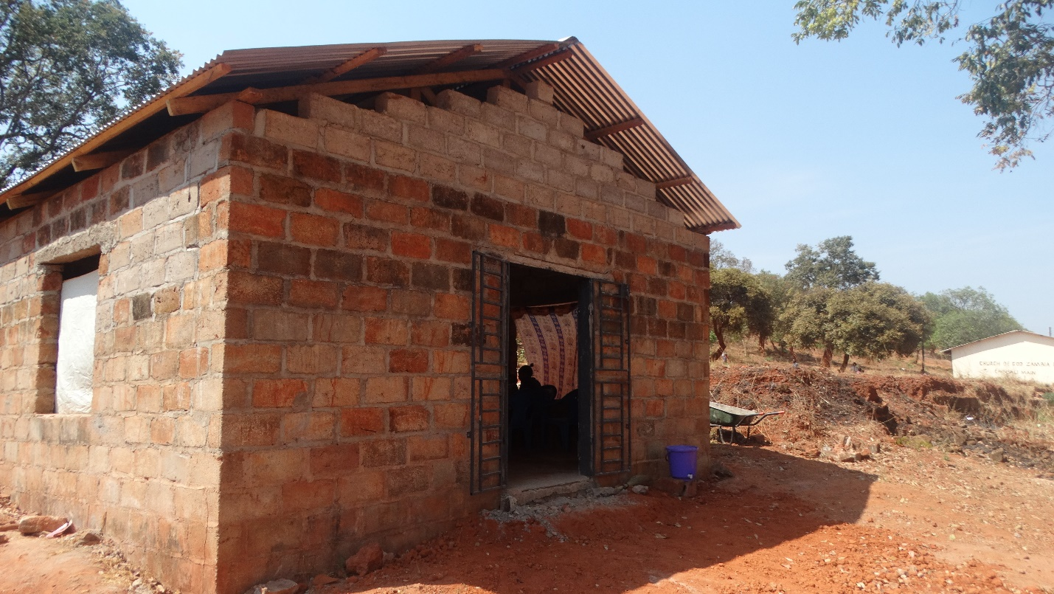
On our first day with the church, we had six individuals respond to be baptized. At this time, it appears that the photos have been lost. I am still searching but cannot locate them. If/when I do I will share them.

I asked Charles if we are helping the church. He said, “yes, very much.” As a congregation they are small but seem to be strongly united.

The number in attendance will vary at any given time as individuals leave to deal with issues with children and business. Our time here is scheduled during the week so there will be some who will not be able to miss working.

On our final day we finished the study of Ephesians. There were two who asked to be baptized. After everything was finished, we headed to the river to baptize them.

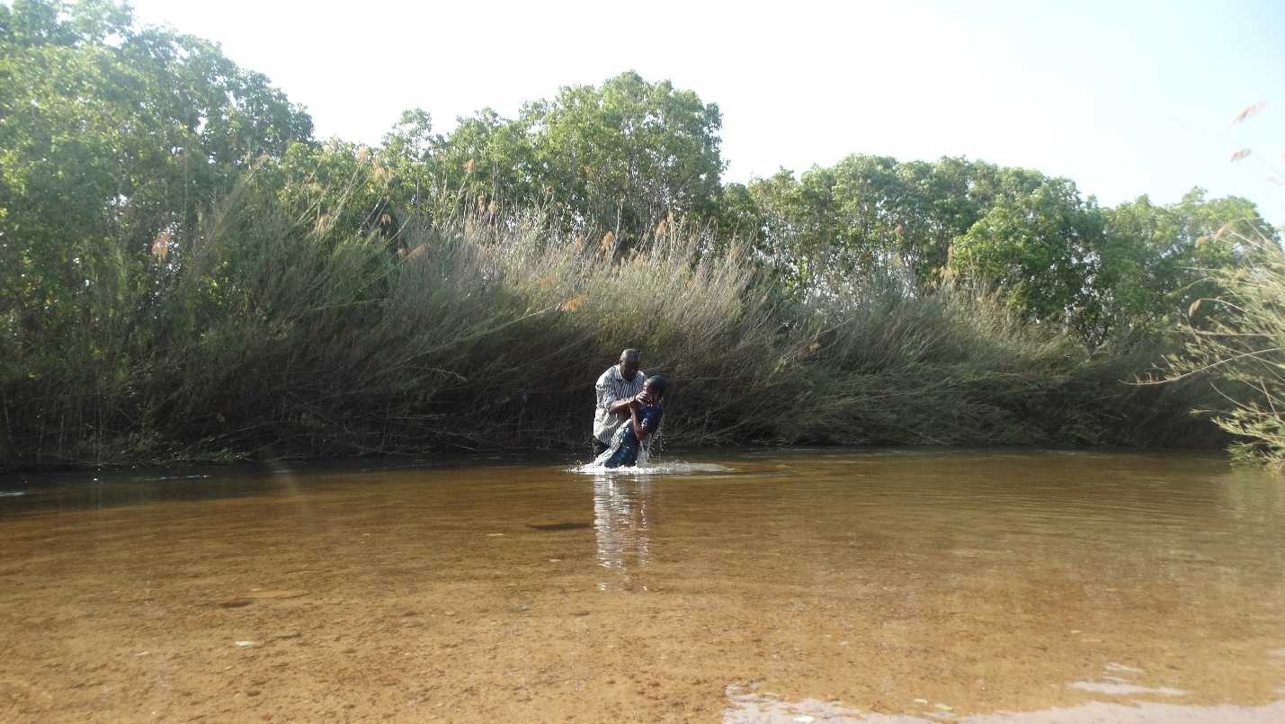
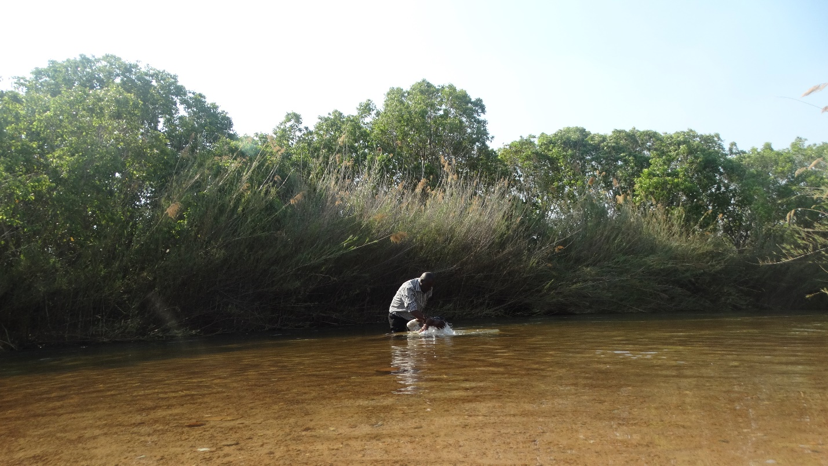

We took our leave to return to the lodging and prepare for departure tomorrow for Serenje. I will be a longer drive at 426km. Until then…

God bless!
Charles
Chinsali, Zambia

